Correcting Misleading Visualizations: The Case of COVID-19 Data Representation

Introduction
Data visualizations are essential tools for communicating information effectively. However, poorly designed visualizations can mislead viewers and distort data interpretation. In this paper, we analyze the initial version of our COVID-19 case map, identify the misleading aspects, and discuss how we improved the visualization for better clarity and accuracy.

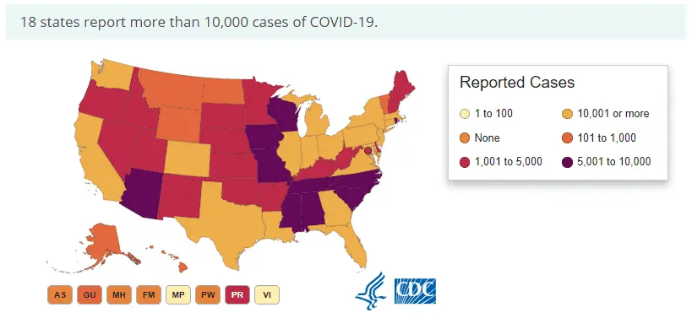

Issues with the Initial Visualization
The COVID-19 case map has several misleading elements. One major issue was the color scheme, which did not align with standard visual conventions. Typically, maps are wired to interpret the darkest or strongest colors as representing the highest values, while the lightest colors indicate the lowest values.
However, the map went against this assumption, using a lighter shade for the highest number of COVID-19 cases and darker shades for lower counts. This counterintuitive approach made it difficult for viewers to quickly grasp the severity of the situation. Additionally, the colors were not logically structured, making it even more confusing to differentiate between case ranges.

Improvements and Fixes
To correct these issues, we implemented several key improvements. First, we refined the color scheme to align with standard expectations, ensuring that darker colors represented higher case numbers and lighter colors indicated lower values. This adjustment made it easier for viewers to instinctively understand the data without confusion. Additionally, we ensured that the color transitions were more logically structured, providing a clearer visual distinction between different case categories.
We also introduced numerical labels directly onto the map, allowing viewers to see exact case counts rather than relying solely on color coding. This addition improved clarity and ensured that each state’s case count was explicitly displayed. By incorporating these changes, we transformed the visualization into a more accurate and comprehensible representation of the COVID-19 data.

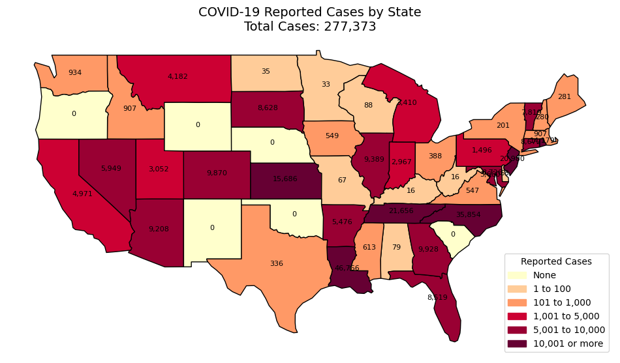

Conclusion
A well-designed visualization should enhance understanding, not create confusion. Our initial COVID-19 case map contained misleading elements, but by refining the color proportions, using a more logical color scheme, and including case numbers, we improved its accuracy and readability. Ethical data visualization is critical in ensuring that information is communicated effectively and responsibly, particularly when dealing with public health data.

